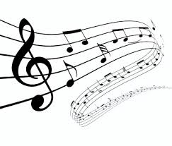
Tone and Mood in Music
How does music make you feel? In the boxes below, illustrate how each of the four songs makes you feel.

1) | 2)
3) | 4)

Notes: Tone, Mood, and Imagery

- What is the definition of tone?

- What is the definition of mood?
- List five examples of words that identify tone.

- How do mood and tone differ?

- What is the definition of imagery?
Tone and Mood in Movies
We will be watching two different trailers for Frozen. In the Venn Diagram below, note how the creator
What mood does that tone evoke?
What mood does that tone evoke?
Commonalities
Frozen, the original trailer
Frozen, as a horror film
How does the creator demonstrate tone?

demonstrates tone (lighting, music, dialogue, etc.), and the mood that is produced.
How does the creator demonstrate tone?

